- Our Brand

Our brand is a combination of our Vision, mission, values, use of logo, words, typeface, design and colours. They all make up the charity’s personality and they help people to recognise and trust us.

- Our Name
We are the Multiple System Atrophy Trust, also referred to as the MSA Trust or the Trust.
The shortened forms should be used after the full name with the acronym in brackets. For example:

- Multiple System Atrophy Trust (MSA Trust) - MSA Trust used subsequently in the body of the text.
- Multiple System Atrophy Trust (the Trust) – the Trust used subsequently in the body of the text.

- Our Colours

Note: The Secondary colour RGB code below is incorrect. It should be 120 200 211.
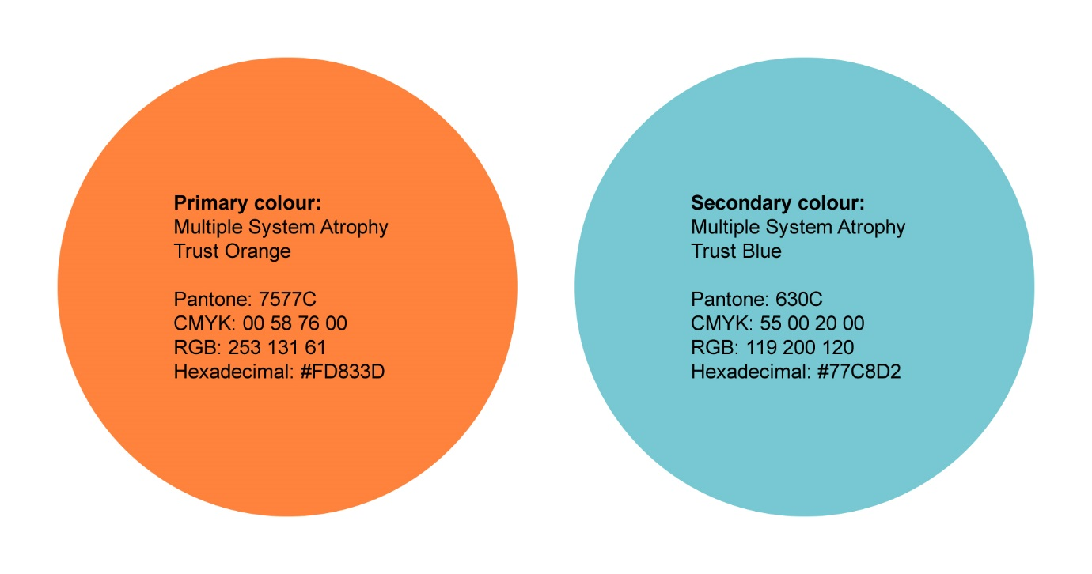
Our new colours for our new website:

COLOURS:

Purple (get involved) #6202FE
Black #1A1A1A
Orange #FD833D
Off white #F2F8F3
Green (research) #325E5D
Light Green #DFE9E4

- Our Logo





- Our Typefaces

The preferred typeface for use on professionally produced is Arial.
Standard body copy should be 11pt with 14pt bold for main headings (use 14pt sparingly, however). Arial bold in 11pt or 12pt can be used for sub-headings. Using dark blue as a subheading colour on information resources and the website is acceptable to help break up text.

Arial regular:
ABCDEFGHIJKLMNOPQRSTUVWXYZ
abcdefghijklmnopqurstuvwxyz
1234567890

Arial bold:
ABCDEFGHIJKLMNOPQRSTUVWXYZ
abcdefghijklmnopqurstuvwxyz
1234567890

Our website uses the font ‘Quicksand’.

