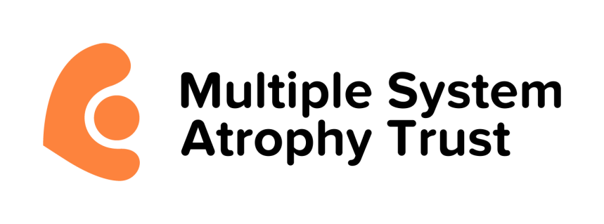

MSA Trust Supporter Media Pack
A simple guide to help you share your story, raise awareness, and speak confidently about multiple system atrophy (MSA).
About This Pack
This media pack is designed for MSA Trust supporters who want to raise awareness or share their personal story.
It gives you:
- Clear guidance on what you can say
- What to avoid
- How to focus on your personal story
- How to share your story with the MSA Trust
- How to approach local press, radio, or TV
- Where to find accurate information
Everything here is based on publicly available information from the MSA Trust website.
Talking About MSA: What You Can Say
You can use general information from the MSA Trust website, such as:
- Multiple system atrophy (MSA) is a rare, progressive neurological condition.
- It affects movement, balance, and the body’s automatic functions.
- The MSA Trust is the leading charity, in the UK and Ireland, dedicated to supporting people affected by MSA.
- The Trust provides specialist support, information, and advocacy for families.
These statements help people understand the condition without going into medical detail.
What You Should Avoid Saying
To keep things accurate, safe, and respectful:
Avoid medical advice
- Don’t describe treatments, medications, or expected timelines.
- Don’t suggest what someone “should” do medically.
Avoid sharing private medical details
Unless you have explicit permission, avoid:
- Specific symptoms
- Medical history
- Sensitive health information
Avoid statistics or claims you’re unsure about
If it’s not on the MSA Trust website, leave it out.
Avoid sharing more than you’re comfortable with
You are always in control of your story.
Emphasising Your Story
Your personal experience is the most powerful part of any awareness-raising.
You can talk about:
- Why you’re supporting the MSA Trust
- How MSA has affected your family, friend, or community
- What support from the Trust has meant to you
- What you want people to understand about the impact of MSA
- Your motivation and your fundraising journey
Sharing Your Story With the MSA Trust
If you’d like your story to be featured on the MSA Trust website or social media:
- Visit the Your Stories section on the MSA Trust website
- Read examples from other supporters
- Contact the Trust support team (support@msatrust.org.uk) to discuss submitting your story
Contacting Local Press, Radio, or TV
You don’t need media contacts. Local media outlets are always looking for community stories, told by those with lived experience.
How to approach them
- Email your local newspaper, radio station, or TV newsroom
- Keep it short and personal
- Explain who you are, your connection to MSA, and what you’re doing
- Include a link to the MSA Trust website for accurate information
What to include
- Your personal motivation
- A photo (if you’re comfortable)
- Details of your event or fundraising
- A simple explanation of MSA (from the Trust website)
How the MSA Trust can support you
- Checking your wording
- Providing general information about MSA
- Offering guidance on how to talk about the charity
- Supporting you if media want more detail
For Supporters With Very Little Time
If you’re caring for someone who is very unwell, here are the simplest ways to raise awareness:
- Share a short social media post in your own words
- Add a link to the MSA Trust website
- Ask a friend or family member to help with admin
- Send a brief email to local press, even a few lines is enough
- Let the MSA Trust team support you with anything more complex
Small actions still make a big difference.
Need Support or Want to Share Your Story?
You can contact the MSA Trust team to:
- Share your story
- Ask for help with wording
- Get guidance on approaching the media
- Learn more about raising awareness
The Trust is here to support you every step of the way.

