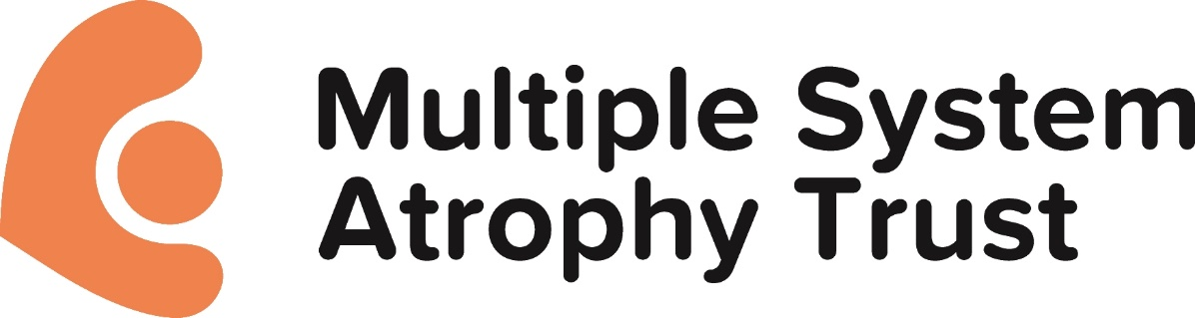

MSA Trust Policy – Stem Cell Research
The Trustees of the Multiple System Atrophy Trust recognise that the issues surrounding embryonic stem cell research and therapeutic cloning give rise to serious ethical and moral questions. In principle, however, they are prepared to fund projects which may involve stem cell research provided it has been satisfactorily demonstrated to them that such research is legal and has both a sound scientific basis and the potential to lead to viable treatments and/or a cure for MSA.

Background information on regulation of stem cell research in the UK
The UK has a well-established regulatory framework for stem cell research. Embryonic stem
cell research is allowed subject to a licence from the Human Fertilisation and Embryology
Authority (HFEA). Licences are granted only if the HFEA is satisfied that any proposed use of
embryos is absolutely necessary for the purposes of the research. Licenced research can only
take place on embryos created in vitro - embryos that have developed from eggs fertilised
outside the body. Licensed research can only take place on embryos up to 14 days. Stem
cells are isolated from the blastocyst much sooner than this – at five to six days. Embryos that
are used must have been donated with appropriate consent or have been created by nonreproductive cloning.
Further details are outlined in the Human Fertilisation and Embryology Act (1990) and the
subsequent Human Fertilisation and Embryology (Research Purposes) Regulations 2001

Adopted by Trustee Board June 2014.
Reviewed in 2021
Next review 2024

