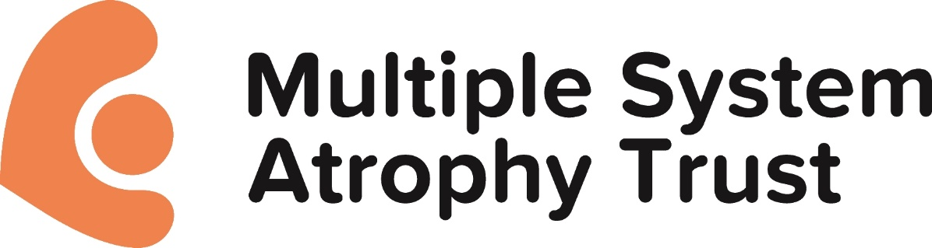

MSA Trust Policy - Research using animals
Multiple System Atrophy Trust Statement on the use of animal tissue and/or live animals in
MSA Research:
There is an urgent need for ongoing research to find the cause and hopefully a cure
for the life ending disease that is multiple system atrophy (MSA). We believe the use
of animals in research is essential to understanding MSA and enabling research to find
a cure.
MSA Trust will only fund and support research involving animals when no realistic
alternatives are available and that any institution preparing to research using animals
can demonstrate they comply with the rigorous laws that safeguard the welfare of
animals used in research both here in the UK and across the EU. As with all funded
research there must be a clear potential benefit to people with MSA.
MSA Trust’s policy is to act responsibly, sensitively and in compliance with both the letter and
the spirit of the law in funding any such project which may involve the use of animal tissue
and/or live animals.
The Trust requires that any application for funding for a project which involves the use of
animals must include review by an animal care and use committee within the host institution.
The following conditions for any such project are to apply at all times:
1. The use of animals must be absolutely necessary.
2. The potential benefits to MSA patients must outweigh the cost to animals.
3. There must be full justification for the animal species and methods used.
4. There must be a clear indication of what the outcome of the research will be.
It is recognised that there are non-animal methods, such as studies of post-mortem human
tissue, computer modelling, studies of patients and populations, which may be of benefit
(sometimes in conjunction with animals) and should be considered in the planning of any
research project submitted to the Trust for funding.
All grant holders using animals must implement the principles in the cross-funder
guidance Responsibility in the Use of Animals in Bioscience Research
(www.nc3rs.org.uk/responsibility).
Grant holders using non-human primates must comply with the NC3Rs guidelines
Primate Accommodation, Care and Use (www.nc3rs.org.uk/primatesguidelines).
Grant holders should make use of the ARRIVE guidelines (www.nc3rs.org.uk/ARRIVE)
when designing their experiments, and ensure that they report animal-based studies in
accordance with the ARRIVE guidelines as far as possible, taking into account the specific
editorial policies of the journal concerned.
We ask that researchers that propose the use of animals in their work complete the
additional page regarding use of animals in their work when they submit funding
applications.

Adopted by Trustee Board, June 2014, reviewed 2021
Next Review: 2024

