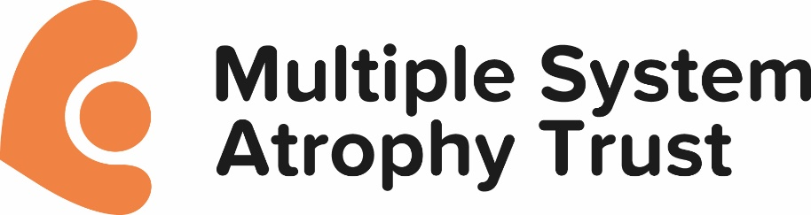

MSA Trust Coronavirus Guidance

The MSA Trust is monitoring closely the advice being given by the UK Government and the NHS. We strongly recommend that everyone follows this - https://www.nhs.uk/conditions/coronavirus-covid-19/ in order to keep yourself as well as you possibly can. Although MSA hasn’t been mentioned specifically, please do bear in mind older adults and those with medical illnesses are more at risk from Coronavirus so extra care is needed.
Given this current advice, we have suspended our Support Groups and our Candlelight Memorial event. We are taking active steps to ensure that our Helpline and MSA Nurse Specialist support services remain available to you.
We will keep posting information on social media and do check back to our website as the situation is incredibly fluid at the moment and changes can happen very quickly.
Our priority as always is to ensure the well-being of our MSA community as far as we possibly can.

Created: 5th March 2020
Updated: 12th March 2020

