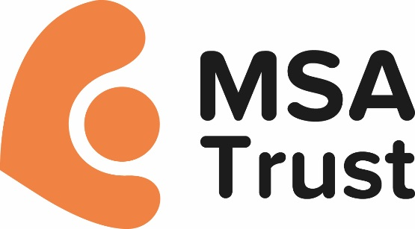

MSA Trust Website Privacy Policy
The MSA Trust is committed to protecting your privacy and this policy explains how we use information you give to us through our website and how we protect your privacy.
This policy only applies to those resources within the msatrust.org.uk domain.
Our Privacy Policy relating to General Data Protection Regulations can be found here.

The Data Protection Act
Under the Data Protection Act 1998, we have a legal duty to protect any information we collect from you. We use leading technologies and encryption software to safeguard our data, and strict security standards to prevent any unauthorised access to it. We do not pass on your details to any third party unless you give us permission to do so.

What information do we collect?
We collect different kinds of information from visitors to msatrust.org.uk. This can include information from:
- feedback (through emails to us via the website)
- registration (for membership and to access to various parts of our website – for example, our Forum)
- online donations
- enquiries about or registration for services or fundraising events
- site usage information, from cookies and log files.

Comments and questions
If you send an email or letter via msatrust.org.uk asking for information, we may need to contact other organisations to find the answer. If your question is technical, we may need to pass it to our technology supplier’s team. We may include your personal information when dealing with your enquiry. When a member of the Trust team has replied to you, they keep a record of your message for at least three months for reference and audit purposes, after which it is deleted.

Site usage information
Log files allow us to record visitors’ use of the site. We analyse log file information from all our visitors and use it to make changes to the layout of the site and to the information in it, based on the way that visitors move around it.
Log files do not contain any personal information and they are not used to identify any individual patterns of use of the site.

What happens when I link to another site?
msatrust.org.uk contains links to other websites. This privacy policy applies only to our site. When you move to another site, read the privacy statement of any site which collects personal information.
We do not pass on any personal information you have given us to any other site.
If this privacy policy changes in any way, we will place an updated version on this page. Regularly reviewing this page ensures you are always aware of the information we collect, how we use it, and under what circumstances, if any, we will share it with other parties.

What happens to the information I supply?
Any details you supply to us are held in strict confidence. If you state you are happy for us to hold your details we may from time to time contact you either by phone, post or email about our work. Should you not wish us to contact you in this way please notify us in writing at the following address:
MSA Trust 51 St. Olav’s Court, Lower Road, SE16 2XB or support@msatrust.org.uk

How do we protect personal information?
We use secure systems when you make a donation or payment via our website. We also take appropriate measures to ensure that the information disclosed to us is kept secure, accurate and up to date and kept only as long as is necessary for the purposes for which it is used.

Contact for queries about our Privacy Policy
If you have any queries about our Privacy Policy or our compliance with the Data Protection Act, please write to:
Deputy CEO (re data security), MSA Trust St Olav’s Court, Lower Road, SE16 2XB
Or email support@msatrust.org.uk
This policy was last updated August 2018 and will be reviewed September 2019.

