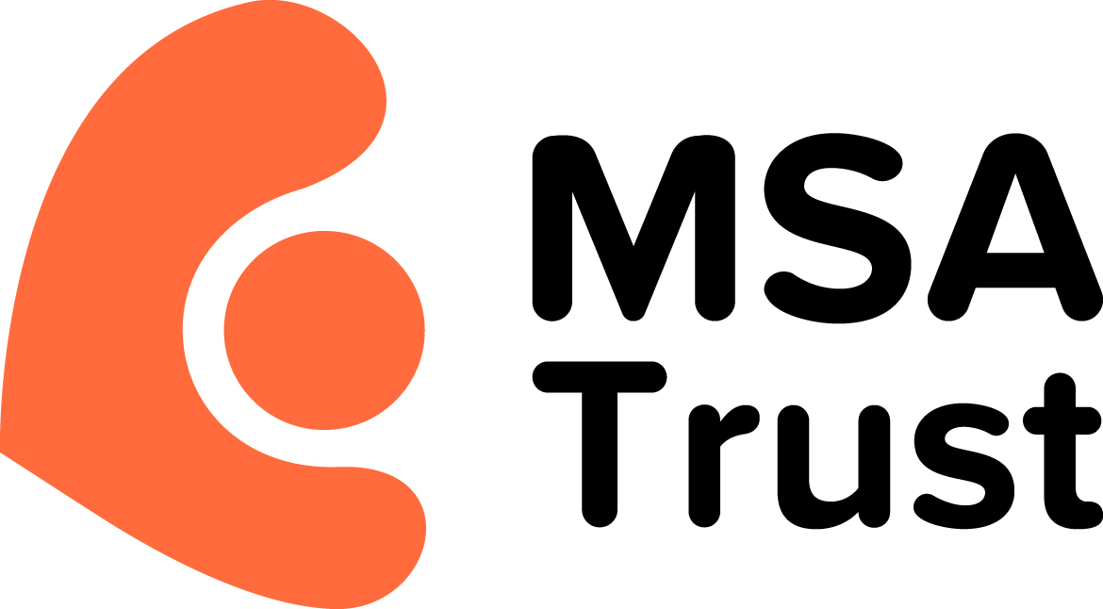

MSA Trust Revised Privacy Policy (GDPR revision)
At the MSA Trust we are committed to providing the best services we can to support people affected by MSA. We are also hugely grateful for the support that people offer us.
We know your personal data and privacy is extremely important to you, and we assure you it is also important to us.
We promise to respect any personal data you share with us, keep it safe and not do anything with it that you would not reasonably expect.
We will never:
- Sell your data to another organisation or third party
- Share your information with another charity without your specific and explicit consent
We will always:
- Do our best to keep your personal details safe
- Treat you fairly and reasonably
- Respond quickly to any changes you want in our contact with you, including if you wish to opt out of future contact from us
Opting Out and Your Rights of Access to Data
If your details change, or you want to change how we communicate with you or want to opt out completely please get in touch with us at support@msatrust.org.uk or call 0333 323 4591. We will then update your records as soon as possible.
You have the right to see what data about yourself we hold on our records. You may use this form here or contact us as above.
How do we Decide Who to Contact and What to Send?
We contact people based on their consent and how they wish to communicate with us.
Sometimes we have to process your data in order for us to comply with our legal obligations, like when we send Gift Aid information to HMRC.
The only situation where we ever provide details to a third-party, other than as above, is where people have said that they want our magazine MSA News to be sent to them by post. We then forward a list on to a mailing company who send MSA News out. We have ensured they also adhere to Data Protection legislation and they securely delete these records once MSA News has been posted.
How we Hold and Process Data
We hold and process data in order to enable us to provide services to people affected by MSA and to undertake our Fundraising activities. Where data is held on databases we have ensured that the suppliers of these are protected under the terms of the Privacy Shield.
We will keep records for seven years before we then set them to do not contact if you do not contact us within this time. You can opt out of contact at any time.
MSA Trust Privacy Policy revised June 2018
Review date due January 2019.

