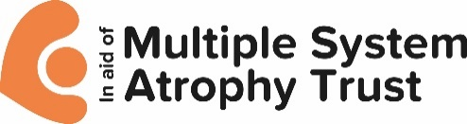

**FOR IMMEDIATE RELEASE Insert** the date that you will send the press release

**Insert a short, catchy title that is one sentence long**

* Write two or three short paragraphs about your event
* Remember to include information about the event, who is participating, when it will happen, where it is taking place and why you’re doing it
* Consider including a quote from a participant, event organiser or even a person with MSA.

Ends

Photos:

Insert link to photo sharing site if you have good photos

Notes to editors:

Multiple system atrophy (MSA) is a rare neurological disease that leads to premature death. It causes brain cells to shrink resulting in severe problems with multiple bodily functions. People with MSA often end up in need of 24/7 care, doubly incontinent and in some cases unable to communicate, swallow or move. Some people with MSA say it feels like the disease traps them in their own bodies. There is no known cause or cure for MSA. It strikes at random and usually when people are in their fifties.

The MSA Trust is the UK and Ireland’s leading charity supporting people affected by MSA. The Trust provides its services free of charge to people affected by MSA – they include MSA Nurse Specialists, a Support Group network and an email and telephone support service. The Trust also funds vital research to find the cause, and one day, cure for MSA.

Contacts:

* **Your name, telephone number and email address**
* **Karen Walker**, Chief Executive, MSA Trust: 0333 323 4591 / 07710 312552 [**karen.walker@msatrust.org.uk**](mailto:karen.walker@msatrust.org.uk)**, www.msatrust.org.uk**