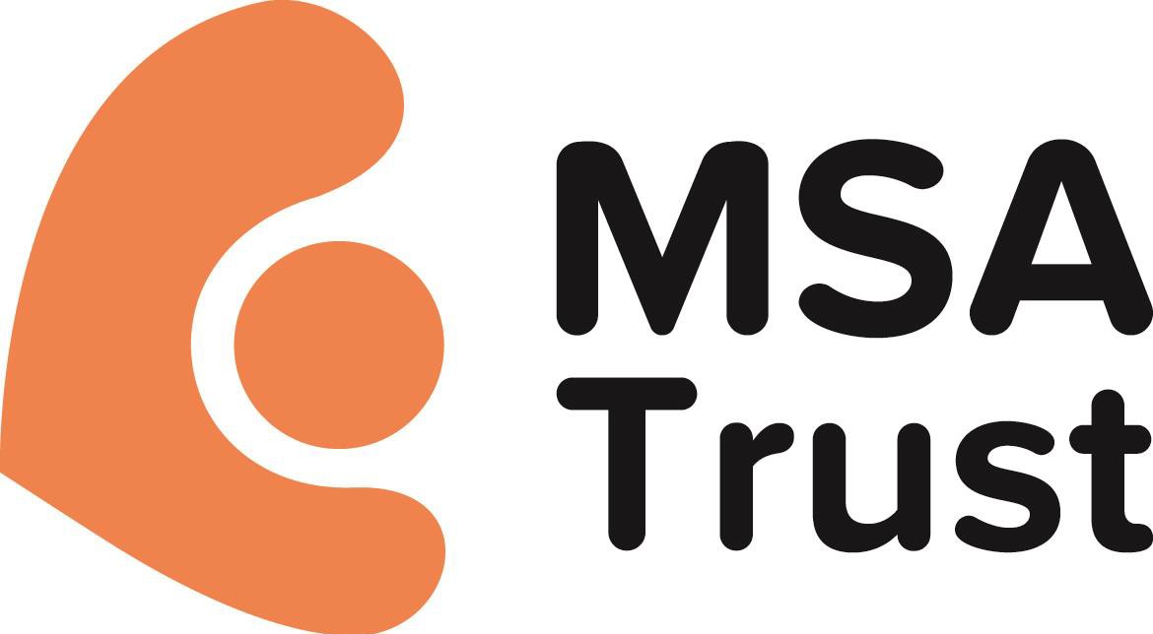
Multiple System Atrophy Trust
51 St Olav’s Court
Lower Road London
SE16 2XB
www.msatrust.org.uk 0333 323 4591

Our vision is a world free of MSA

Dear Sir/Madam,

Thank you for your interest in volunteering with the Multiple System Atrophy Trust. We are the UK’s main support and information service for people who have multiple system atrophy (MSA) – a rare neurological disease with no known cause or cure. We are here to support anyone affected by MSA including family members and carers. We also support health and care professionals who look after and treat people with the disease.

People with MSA, their families and carers live in cities, towns and villages around us. It is vital that we provide support to them and raise awareness of MSA to help tackle the isolation felt by having a rare disease, at a local level, within the communities where they live.

That’s why volunteers are so important to our work. Local people help us to signpost families affected by MSA, raise awareness of MSA within local communities and increase the knowledge of health and care professionals so that they can provide better and more timely treatment and care.

As a charity funded entirely by donations from individuals, companies and charitable trusts, local volunteers also support us by raising vital funds to allow us to continue to offer our services and fund research.

Our volunteers are at the heart of our work and at the heart of every community so that people affected by MSA receive the support they need. We are committed to ensuring volunteers receive the best possible experience whilst volunteering with us, and that they feel fulfilled and valued.

Once you have chosen the volunteer role you would like to apply for, please return your application form to us and we will contact you with details about the selection process for the role you have applied for.

We look forward to receiving your application.

Kindest regards,

The Multiple System Atrophy Trust

We rely entirely on donations, of which legacies are a vital part. Please consider remembering the Trust in your Will.
Patrons: Sir Roger Bannister CBE FRCP and Professor C J Mathias DPhil DSc FRCP The Multiple System Atrophy Trust is a charity registered in England as a limitedcompany.
Company Registration No: 7302036. Registered Charity No. 1137652 (England & Wales) and SC044535 (Scotland)

Volunteering at the Multiple System Atrophy Trust

For information on the different volunteering opportunities available and current vacancies please contact us or visit our website - www.msatrust.org.uk/get-involved/volunteer. Whatever role you choose to do, you’ll be making a vital contribution to our work.

If you have any questions about volunteering please contact us on 0333 323 4591 or email us at
volunteer@msatrust.org.uk

Who can become a volunteer?
We welcome a wide range of volunteers from diverse backgrounds. If you are from the European Union (EU), you are free to volunteer in the UK. For those from outside the EU, you will need to check that your visa allows you to volunteer. We advise that you contact the UK Visas and Immigration Office for further information.

Currently all of our volunteer roles require you to be at least 18 years old.

How do I apply for a volunteer role?
Simply complete the application form as fully as possible, telling us the role you are interested in and the skills and experience you can offer. Once we have received your application we will contact you within ten working days with details of the selection process for the role you have applied for.

What if you don’t have any vacancies?
We recruit volunteers according to the level of need in each area and, as such, not all roles are available in all locations. If you are interested in volunteering with us but there are no current suitable vacancies we will still welcome your application and can contact you as soon as a suitable opportunity becomes available. We hold prospective applications for up to twelve months.

Where do I send my completed application form?
We accept online, printed and handwritten applications. Please send your completed application form to:

Multiple System Atrophy Trust 51 St Olav’s Court
Lower Road London SE16 2XB

or

volunteer@msatrust.org.uk
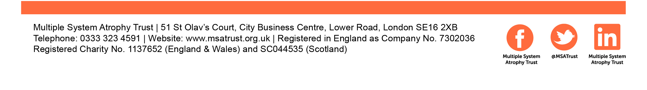
MSA Trust Volunteer Application form
First Name: |  |  | Surname:
Town/City:
Postcode: Mobile phone:

Personal Details

Title: Address: County: Home phone: Email:
How would you prefer us to keep in touch with you?
- Email ☐ Phone ☐ Post
Please note, email is the most efficient and cost-effective method of communication preferred by the Trust

What is your current employment status?
- Employed ☐ Self-employed ☐ Retired ☐ Student ☐ Unemployed

- Other If ‘Other’ please specify:

Emergency Contact Information
Please provide the details of someone we can contact in the unfortunate event that you are injured or taken ill while volunteering.

Emergency contact name:

Phone number: Relationship to you:
Volunteering with us
Which volunteering role are you interested in?
- Support Group Leader

- Office Volunteer

- Trustee

- Helping Hands Volunteer (please use separate application form)

In which areas do you have skills/experience?

- Administration ☐ Campaigning

- Data entry ☐ Digital media

- Event management ☐ Fundraising

- Health and care professional ☐ IT

- Leadership ☐ Media and PR

- People management ☐ Presentation/public speaking

- Project management ☐Recruitment and selection

- Research ☐Science communication

- Trustee positions ☐ Understanding of MSA

- Volunteer management ☐ Website editing

When are you able to volunteer?

Monday | ☐am | ☐pm | Tuesday | ☐am | ☐pm | Wednesday | ☐am | ☐pm
Thursday | ☐am | ☐pm | Friday | ☐am | ☐pm | Saturday | ☐am | ☐pm
Sunday | ☐am | ☐pm

☐ I am totally flexible about when I can volunteer

Please tell us why you would like to volunteer for the Multiple System Atrophy Trust and any relevant experience you have:

Please tell us how you heard about volunteering at the MSA Trust:
References

Please provide details of two people who will be able to offer a reference about your ability to act as a volunteer with us. Referees cannot be family relations to you and the person must have known you for at least two years.
Reference 1

Name: Relationship to you:

Address:

Phone number: Email:

Reference 2

Name: Relationship to you:

Address:

Phone number: Email:

Are you prepared to complete a DBS application if needed? ☐ Yes ☐ No
Declaration

- I declare to the best of my knowledge, the information I have given is complete and accurate.

- I consent to my data being processed and kept in accordance with the Data Protection Act 1998.
- I hereby give consent for the Multiple System Atrophy Trust to contact the referees I have provided.

Signed: Date:
FOR OFFICE USE ONLY
Date received: |  | Logged on RE:
Constituent ID:

Reference 1 collected:
 |  | Reference 2 collected:
Induction date: |  | Appointment date:

