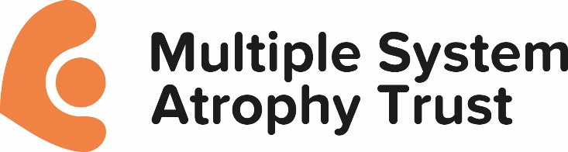

**Multiple System Atrophy Trust: Research Grant and Peer Review Process**

**Eligibility**

Following a submission of a pre-proposal application, assessment is made by SAP and eligible candidates are invited to submit a full application.

Research grants are considered from applicants from within the UK and Europe in the first instance and must meet UK standards of research ethics, scientific integrity and animal welfare.

Research applicants must accept the Trust’s Grant Terms and Conditions, including the policy on protection of intellectual property rights stated within the Grant Terms and Conditions.

**Amount and Scope**

The Trust awards project grants up to a maximum of £150,000. These grants can be for a period of 1 – 3 years.

The Trust recognises the value of clinical trials and is open to proposals to work in partnership and collaboration with other research funders, professional associations and the pharmaceutical and biotechnology industries. However, providing sole funding is currently beyond our means.

**Evaluation**

Grants are awarded on the basis of relevance to the Trust’s Research Strategy and scientific merit. The charity is a member of the Association of Medical Research Charities (AMRC) and supports their policies on peer review, good research practice, the use of animals in research, testing on human embryos and stem cells

**The Trust’s Peer Review Process**

Applications are considered by the Trust’s independent Scientific Advisory Panel (SAP); these are assessed by a structured peer review process and in accordance with the AMRC stance on accountability, balance, independence, rotation of advisers and impartiality. The process is as outlined below:

* Grant Round is publicised, with the themes outlined and the dates for submission of pre-proposal applications, these are provided on 2 pages and outline the focus of the research project with an estimated budget requirement.
* SAP meets to discuss pre-proposals and agreement is reached on the successful candidates to take their proposal to a full application.
* Candidates are advised if they are successful and can progress to a full grant request.
* Applications completed on the Trust’s Grant Application Form, in line with our Research Strategy and with acceptance of our Terms and Conditions, are submitted to the Trust’s office.
* Two independent external reviewers drawn from experts within the UK and Europe provide detailed written comments and an overall score on each application using Trust grant templates and with full knowledge of Trust grant criteria
* SAP members assess applications using the external reviewers’ completed templates
* A meeting of SAP members allows each member to present the application they have been asked to review by the Chair
* SAP members grade applications
* SAP recommendations are conveyed to the MSA Trust Trustee Board for final agreement on grant awards by the SAP Chair
* Panel members, external referees, Trust staff and applicants agree to abide by the Code of Conduct
* A Conflict of Interest Policy is in place to which all SAP members abide.

Reviewed June 2024

Next review due June 2027

Scientific Advisory Panel