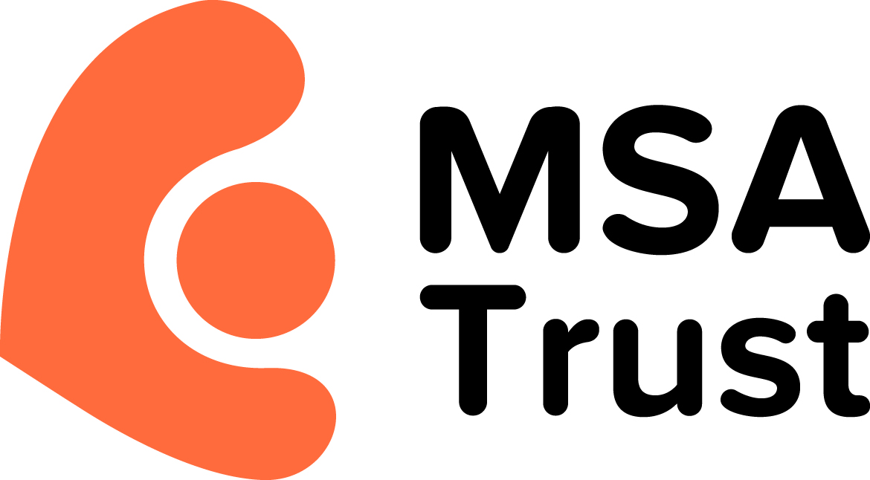

MSA Trust Forum Rules and Guidelines

Please read the following rules before using the MSA Trust forum. They have been created to help protect the users and, by following them, gain maximum benefit from the forum.
The forum is a place to share experiences and provide strength and support to people affected by MSA. It is for debate and discussion about daily life with MSA, treatments and therapies. It is not intended as a place to seek medical advice and users should note that any medical advice given may be inaccurate. No advice should be considered as being delivered by a health or social care professional unless the MSA Trust identifies it as so.
The MSA Trust cannot be held responsible for any information or advice given by users of the forum. If you need advice or information about MSA then please contact our Specialist Nurses. Their details can be found at: http://www.msatrust.org.uk/the-trust/msa-specialist-nurses/
The MSA Forum is operated by The Multiple System Atrophy Trust. The MSA Trust is a charity registered in England and Wales under the charity number 1137652 and our registered office is at 51 St Olav’s Court, Lower Road, London SE16 2XB.
By participating in the forum you agree to the following Rules.

1. Purpose of the forum:
The purpose of the forum is to provide a safe virtual support network for people affected by MSA; to enable them to share experiences and information and help each other cope with the difficulties of everyday life with MSA.
2. Accessing the forum:
- You must register in order to post contributions to the forum.
- Participation in the forum is at your own risk.
- You must agree to the MSA Forum Rules in order to contribute to the forum.
- You must not share your password or other security details with any other person or organisation.
- You must notify us if you suspect that your username has become known to any unauthorised user.
- We do not provide any guarantee that materials accessed through the forum, posted by another individual, are free from viruses of faults.
- The forum is moderated for medical related content by an MSA Nurse Specialist and by the forum administrator for all other content. They have the right to edit or delete content for any reason.
- The Forum is not a substitute for professional advice. You should consult the Trust’s MSA Specialist Nurses, your doctor or other relevant professional before making any decisions that could affect you or others.
3. Online conduct:
- Please do not use the discussion forum to: attack others, make inflammatory remarks, upload/post or email any content that is unlawful, defamatory, abusive, threatening, harmful, obscene, profane, sexually oriented or explicit or invasive of another's privacy.
- Do not upload, post or email any content that is hateful or racially, religiously, ethnically or otherwise objectionable material.
- Do not publish email addresses, the content of email or private messages, telephone numbers or personal contact information in posts.
- Do not post messages advertising commercial products or services, 'junk mail', 'spam', 'chain letters' or any other form of solicitation.
- Religion and politics are important issues in the world but unfortunately they tend to lead to heated discussion. This is a forum dedicated to supporting people so please keep discussions friendly and amicable.
- Do not post links to external websites which are not relevant to the topic of discussion, or promote your own business – these will be removed.
- Do not upload, post or email any content that infringes any intellectual property rights of any party. See point 6 below for further information.
Any posts or threads found in violation of these rules will be edited or deleted. Persistent abuse of the rules will result in suspension and possible deletion of your account.
4. MSA Trust activities on the forum:
- Any individual or organisation, other than the MSA Trust, must not use the forum to gather information for research, surveys or similar activities.
- From time to time the Trust will include surveys and questionnaires or seek feedback on issues relating to MSA care and treatment. If you participate in these activities you are giving the MSA Trust your permission to use the information provided in any appropriate way. Information gathered will always be anonymous and will not be used to identify any individual.
- You grant to us a worldwide, royalty-free, irrevocable, non-exclusive licence (including the right to sub-license) to use, reproduce, modify, adapt, publish, translate, create derivative works from, distribute, perform and display any content (in whole or part) you post and/or to incorporate such content in other works in any form, media or technology now known or developed.
5. Private Messaging:
- The forum operates an ‘opt in’ private messaging function for you to support each other. Please do not abuse the private messaging system and, by opting in, you agree to abide by the same set of rules listed in points 2 and 3 above.
- The MSA Trust has no responsibility for the content of private messages exchanged between forum users. If any information is offered through the private messaging system that you are unsure about please get in touch with the Trust’s MSA Specialist Nurses.
6. Copyright:
- Information copyrighted or owned by any individual or entity other than the posting member should not be posted on the discussion forum without the consent of the owner.
- You may not violate, plagiarise or infringe on the rights of third parties including copyright, trademark, trade secret, privacy, personal, publicity or proprietary rights. If such an event occurs, the individual posting the information shall be held solely responsible.
- The MSA Trust shall not be held responsible for information posted by a forum user that may violate copyright law.

7. Suspension and termination:
- Once we are made aware of activities that breach our forum rules, action will be taken. This may include, at our discretion, modifying or deleting posts or suspending or banning users. If you witness such breaches in the forum or anywhere else in our site, please notify office@msatrust.org.uk immediately.
- In the event of serious breaches we may report your activities to your internet service provider or take legal action against you where our rights or third party rights are threatened or infringed.
- You acknowledge that we have the right to modify or delete any or all information relating to a user, including deletion of a user's account (whether temporarily or permanently) without prior notice or reason.
- You acknowledge that any information posted to publicly accessible areas may remain publicly accessible indefinitely. The MSA Trust is under no obligation to remove content from the site once it has been posted.

8. Disclaimer:
- All communications made available as part of this forum, and any opinions, advice, statements, views or other information expressed in this forum are solely provided by, and the responsibility of, the person posting such communication and not of the MSA Trust.
- The MSA Trust does not certify or endorse the contents of any communication posted to the forums.
- The MSA Trust is not responsible for defamatory, offensive or illegal conduct of any author posting to this forum.

9. Our Liability
- We are not responsible for any loss or damage that you incur in connection with the Forum; in particular we are not responsible for any misuse of your information by other members of the Forum or any member of the public who abuses his or her access to the Forum.
- Clause 9a does not purport to exclude any liability that cannot legally be excluded or limited.
- You shall indemnify us against all losses and/or liabilities incurred by us as a result of your breach of these Rules.

10. Changes to terms and conditions

These terms and conditions are subject to change at any time without notice. If you have any concerns about posts or users in the forum, please contact support@msatrust.org.uk



